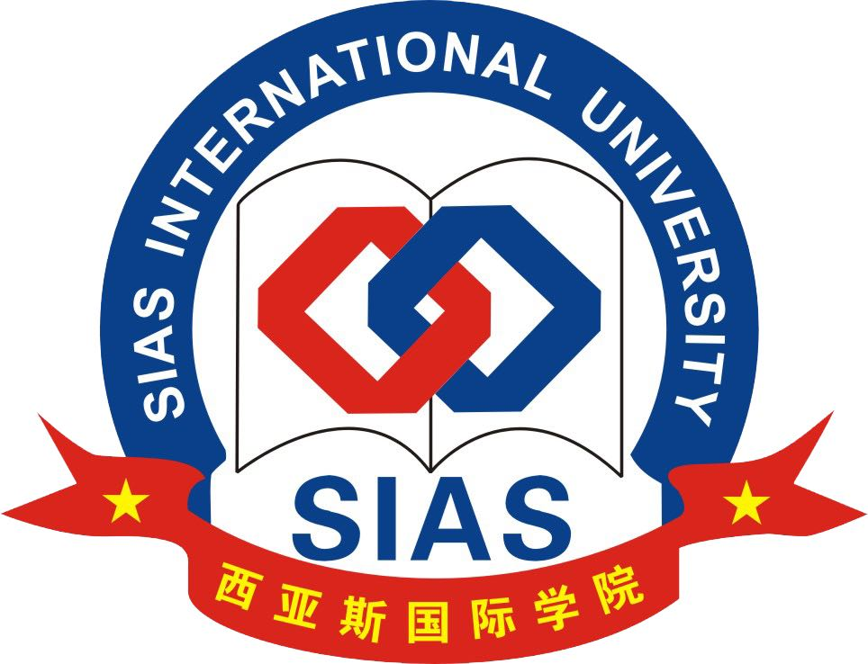

REGISTRATION FORM
The 1st AUAP Inter-University Cheerleading Competition

September 16-24, 2018
Sias International University, Zhengzhou, China

*******************************************************************************●Please type and return the completed form to the AUAP Secretariat by email at auapheadquarters@aunap.org.com / on or before May 20, 2018.

Coaches:

I. Personal Data:  Asst. Prof./  Assoc. Prof./  Prof.Dr./  Dr./  Mr./  Mrs./  Ms. (1st Coach)
First Name: Family Name:
Position: Institution:
Passport No.: Date of Issue: Date of Expire: ………….Date of Birth:……………..
Mailing Address:
Country: Email:
Telephone:

II. Personal Data:  Asst. Prof./  Assoc. Prof./  Prof.Dr./  Dr./  Mr./  Mrs./  Ms. (2nd Coach)
First Name: Family Name:
Position: Institution:
Passport No.: Date of Issue: Date of Expire: ………….Date of Birth:……………..
Mailing Address:
Country: Email:
Telephone:

III. Name of Prayers :  Attached

IV. Payment of Registration 280 USD per each person (AUAP Member)
300 USD per person (Non member)

 I have already forwarded the registration fee of USD (Full Payment) by bank transfer to

Beneficiary Bank: Siam Commercial Bank Public Company Limited
Beneficiary: SUT-AUAP Petty Cash
Beneficiary A/C No: 707-220205-4 ; SWIFT CODE: SICOTHBK
Address: Technopolis Building, Suranaree University of Technology, 111 University Avenue,
Muang District, Nakhon Ratchasima 30000, Thailand

V. Arrival and Departure at Zhengzhou International Airport (CGO), Zhengzhou, China.
Date & Time of Arrival: Flight No:
Date & Time of Departure: Flight No:

VI. Please specify any food restrictions:

Signature
Date

Remarks:

- Registration fee: (accommodation, meals, pick up and send back to the airport) are included.

- Registration: Completed registration form must be submitted on or before May 20, 2018
Contact: to AUAP Secretariat, email: auapheadquarters@aunap.org

- Payment Method: By bank transfer full payment including bank charge

- Prize:

There are 7 competitions and the propose rewards for each competition are:

a) 1st Place: Trophy, money 300 USD and certificate
b) 2nd Place: Trophy, money 200 USD and certificate
c) 3rd Place: Trophy, money 100 USD and certificate

- Airports pick up and drop off at Zhengzhou International Airport (CGO): Sias will arrange a bus (30 minutes) to Sias Hotel (upon travel information given), at no cost.

Please see more details at www.aunap.org

